| CLASS : T. E. 8(E &TC) | SUBJECT : DC |
| --- | --- |
| EXPT. NO. : 8  Roll No :32457 | DATE :04/12/2021 |

TITLE : DIRECT SEQUENCE SPREAD SPECTRUM MODULATION AND DEMODULATION TECHNIQUE

PREREQUISITES

| FOR EXPT. | : Line coding techniques,  BPSK and QPSK modulation demodulation technique, PN sequence generation technique, Concept of DSS technique. |
| --- | --- |
| OBJECTIVE | : To study direct sequence spread spectrum  BPSK modulation and demodulation technique. |
| APPARATUS | :  Sr. Apparatus Range  No.   1. DSSS kit 2. DSO Dual Channel, 60 MHz |

THEORY : Spread Spectrum techniques were and are still used in military applications, because of their high security, and their less susceptibility to interference from other parties. In this technique, multiple users share the same bandwidth, without significantly interfering with each other. The spreading waveform is controlled by a Pseudo-Noise (PN) sequence, which is a binary random sequence. This PN is then multiplied with the original baseband signal, which has a lower frequency, which yields a spread waveform that has a noise like properties. In the receiver, the opposite happens, when the pass band signal is first demodulated, and then despreads using the same PN waveform. An important factor here is the synchronization between the two generated sequences. In this report, I will try to illustrate the design process of such a system, and then come up with a full circuit design.

# Pseudo Noise (PN)

As we mentioned earlier, PN is the key factor in DS-SS systems. A Pseudo Noise or Pseudorandom sequence is a binary sequence with an autocorrelation that resembles, over a period, the autocorrelation of a random binary sequence [Rap96]. It is generated using a Shift Register, and a Combinational Logic circuit as its feedback. The Logic Circuit determines the PN words. In this design i used the so-called Maximum–Length PN sequence. It is a sequence of period 2m. 1 generated by a linear feedback shift register, which has feedback logic of only modulo–2 adders (XOR Gates). Some properties of the Maximum– Length sequences are:

In each period of a maximum–length sequence, the number of 1s is always one more than the number of 0s. This is called the Balance property.

Among the runs of 1s and 0s in each period of such sequence, one–half the runs of each kind are of length one, one–fourth are of length two, one– eighth are of length three, and so on. This is called the Run property.

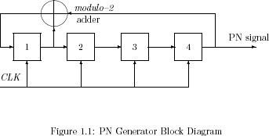

The Autocorrelation function of such sequence is periodic and binary valued. This is called the Correlation property1.

A block diagram of a Maximum–Length PN generator is shown in fig.1.1 with a 4–bit register and one modulo–2 adder. This has a period of 24 .1 = 15, and it was the configuration used in this design as we will show later.

# Direct Sequence - Spread Spectrum

In Direct Sequence-Spread Spectrum the baseband waveform is multiplied by the PN sequence. The PN is produced using a PN generator. Frequency of the PN is higher than the Data signal. This generator consists of a shift register, and a logic circuit that determines the PN signal. After spreading, the signal is modulated and transmitted. The most widely modulation scheme is BPSK (Binary Phase Shift Keying). The equation that represents this DS-SS signal is shown in eq.(1.1), and the block diagram is shown in fig.(1.2).



(1.1) where m(t) is the data sequence, p(t) is the PN spreading sequence, fc is the carrier frequency, and . is the carrier phase angle at t=0. Each symbol in m(t) represents a data symbol and has a duration of Ts . Each pulse in p(t) represents a chip, and has a duration of Tc. The transitions of the data symbols and chips coincide such that the ratio Ts to Tc is an integer [Rap96]. The waveforms m(t) and p(t) are shown in fig.(1.3). Here we notice the higher frequency of the spreading signal p(t). The resulting spread signal is then modulated using the BPSK scheme. The carrier frequency fc should have a frequency at least 5 times the chip frequency p(t).

In the demodulator section, we simply reverse the process. We Demodulate the BPSK signal first, Low Pass Filter the signal, and then Dispread the filtered signal, to obtain the original message. The process is described by the following equations:



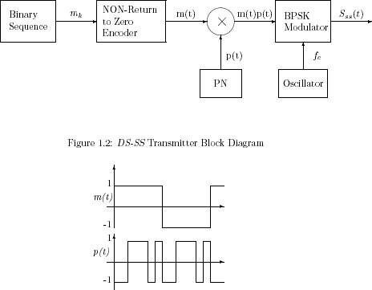

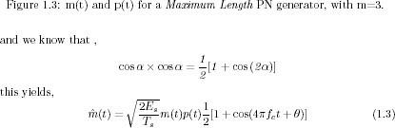

As shown in eq.(1.2)and eq.(1.3) when we multiply two cosine signals together, we will obtain two expressions, one of which has twice the frequency of the original message. And this part can be removed by a LPF. The output is mss(t) as shown in fig.(1.4). My design is based on Coherent Detection BPSK, so we don’t have to worry about carrier synchronization issues.

As for the PN sequence in the receiver, i mentioned earlier that it should be an exact replica of the one used in the transmitter, with no delays, cause this might cause severe errors in the incoming message. Again, my design is based on the idea that PN sequences are matched, and actually i am going to use the same generator for both to ease the design. There are various techniques that deals with PN delay problems and mismatches, but i am not going to encounter any in this design.

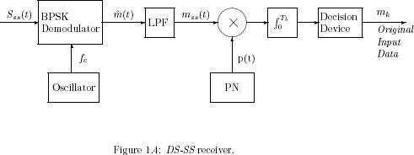

After the signal gets multiplied with the PN sequence, the signal dispreads, and we obtain the original bit signal m(t), that was transmitted. The block diagram of the receiver is shown in fig.(1.4).

This simple straightforward description of DS-SS systems, will allow us to design the Modulator / Demodulator circuits with some ease. We are going to take advantage of the block diagrams for each one of them.

PROCEDURE:



OBSERVATIONS AND GRAPHS:

Plot all above-mentioned waveforms with proper proportion.

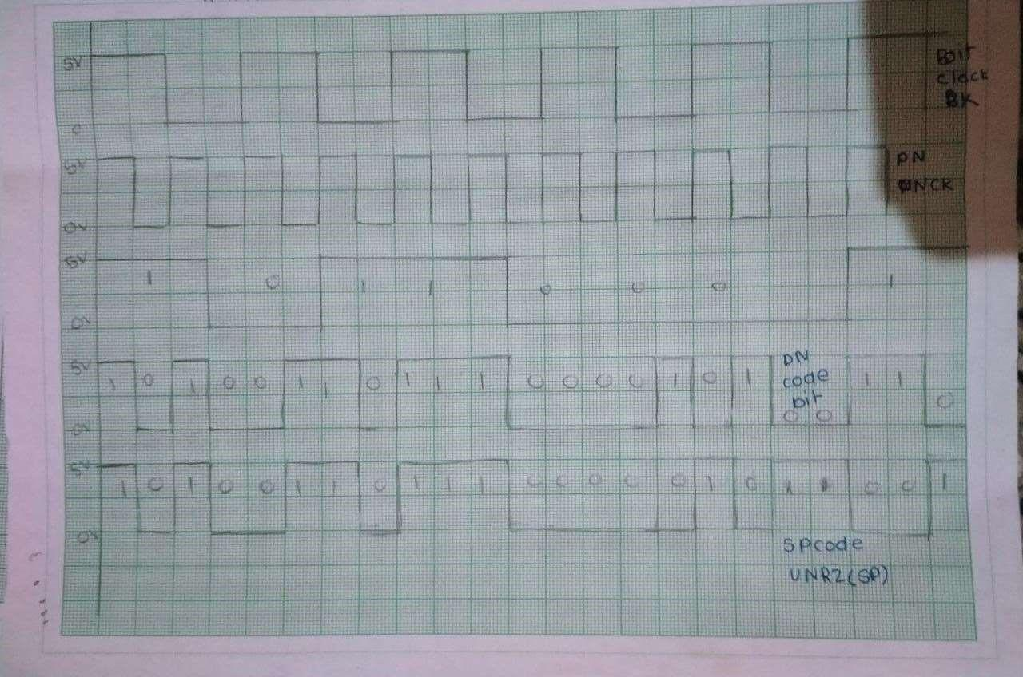

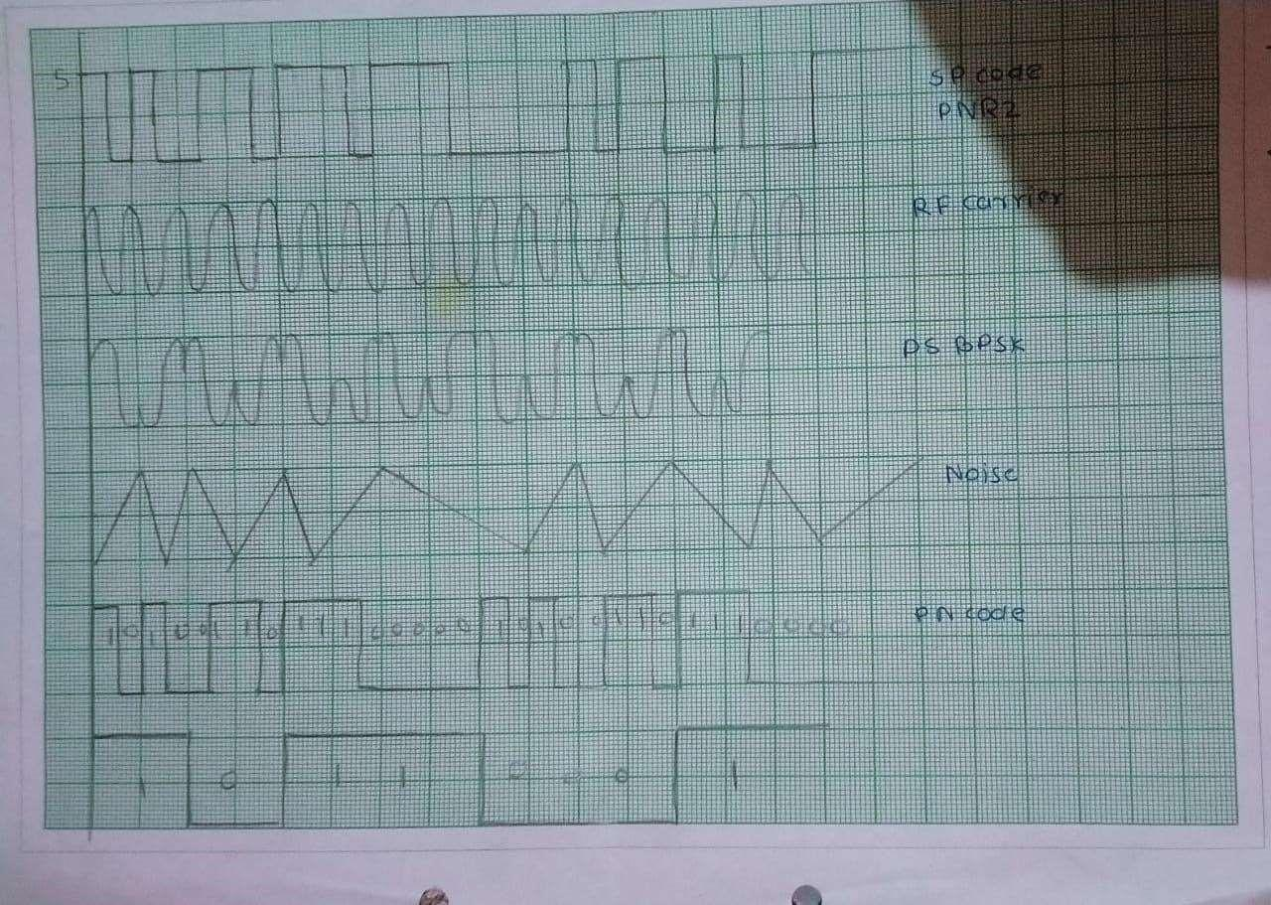

CONCLUSION:

1. Learn about direct sequence spread spectrum
2. We also learn about BPSK modulation

RERFERENCES:

1. Modern Digital & Analog communication system-B.P.Lathi
2. Sigma Trainer Manual
3. “Communication Systems”- Carlson
4. “Principles of Communication System”- Taub-schilling.

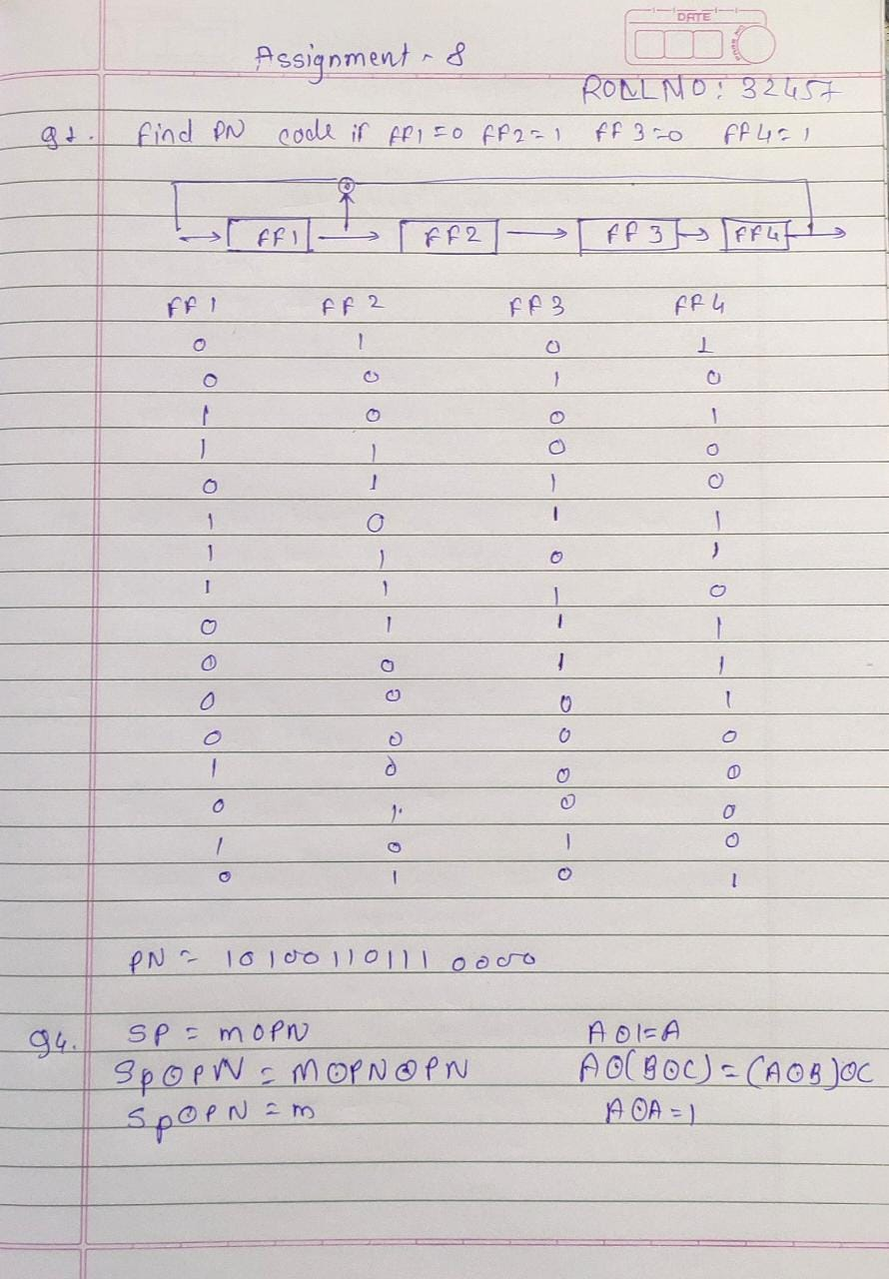

s

